7 CLASSY ELEGANT VALENTINE’S DINNER OUTFITS (OLD MONEY VIBE)

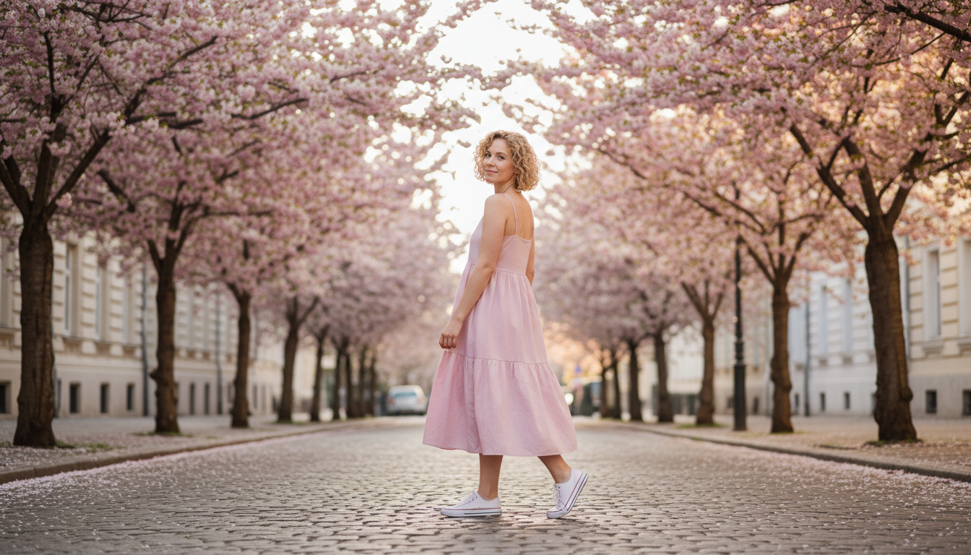

Finding the perfect look for a romantic night out can feel like a big deal. You want to look polished and expensive without trying too hard. This year is all about that quiet luxury aesthetic that everyone loves. If you are planning a fancy meal, these 7 Classy Elegant Valentine’s Dinner Outfits (Old Money Vibe) will help you look your best. We are focusing on high quality fabrics and timeless shapes. Think silk, wool, and pearls. It is about looking like you have had these pieces in your closet forever. You will feel so confident walking into any restaurant. Make sure you read through these to find your favorite look.

# Silk Slip Dress and Oversized Blazer

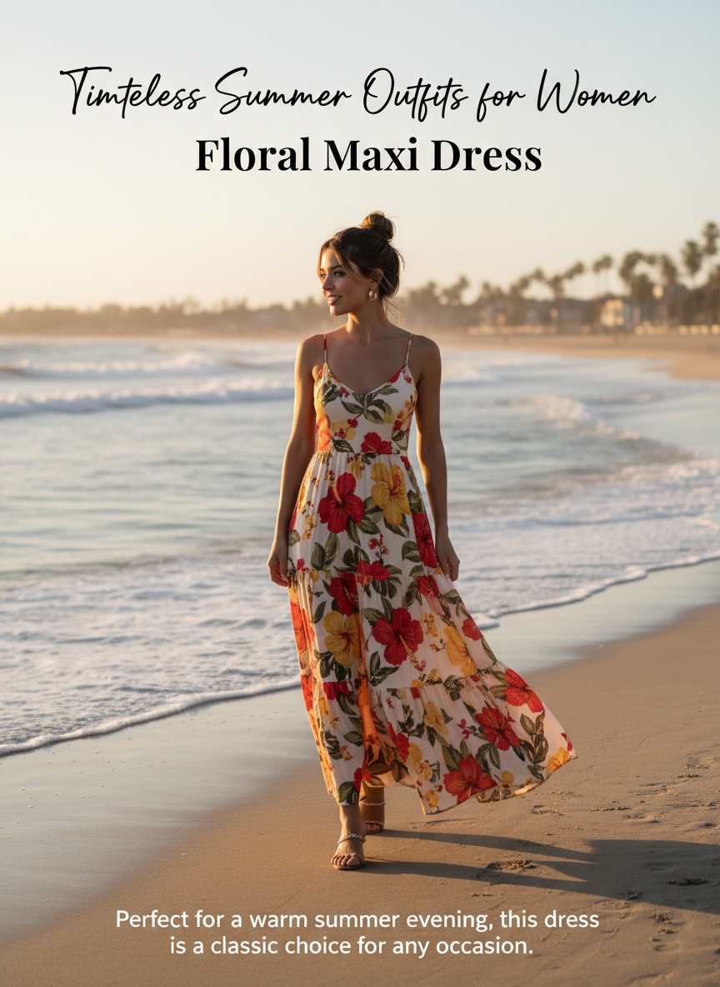

A long champagne silk dress is the ultimate staple for a romantic night. Pairing it with a structured blazer gives it that expensive feel. It balances the delicate fabric with something a bit more masculine. Add some gold jewelry and a simple clutch to finish it off.

# Tweed Skirt Suit

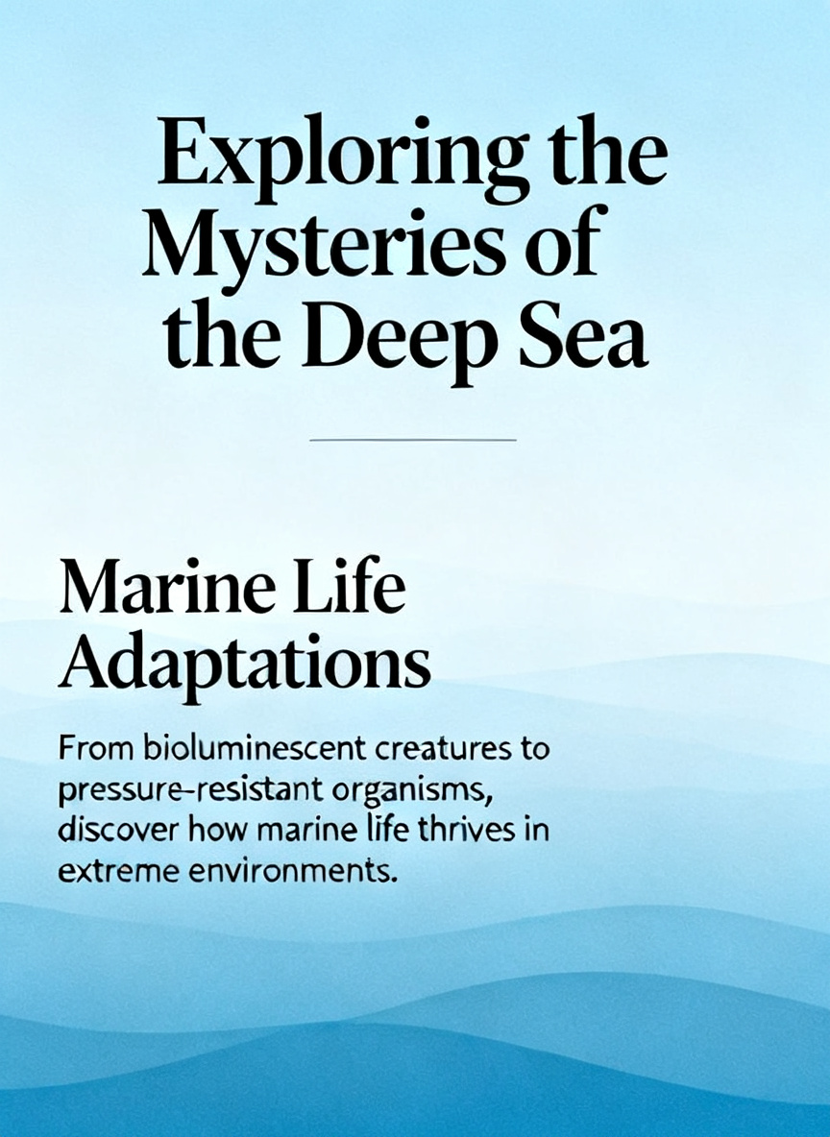

Tweed always screams old money. Pick a set in a soft pink or cream color to stay on theme for the date. The texture looks very rich and high end. Wear this with some pointed toe heels and a headband. It looks very classic and put together for a nice dinner.

# Velvet Midi Dress

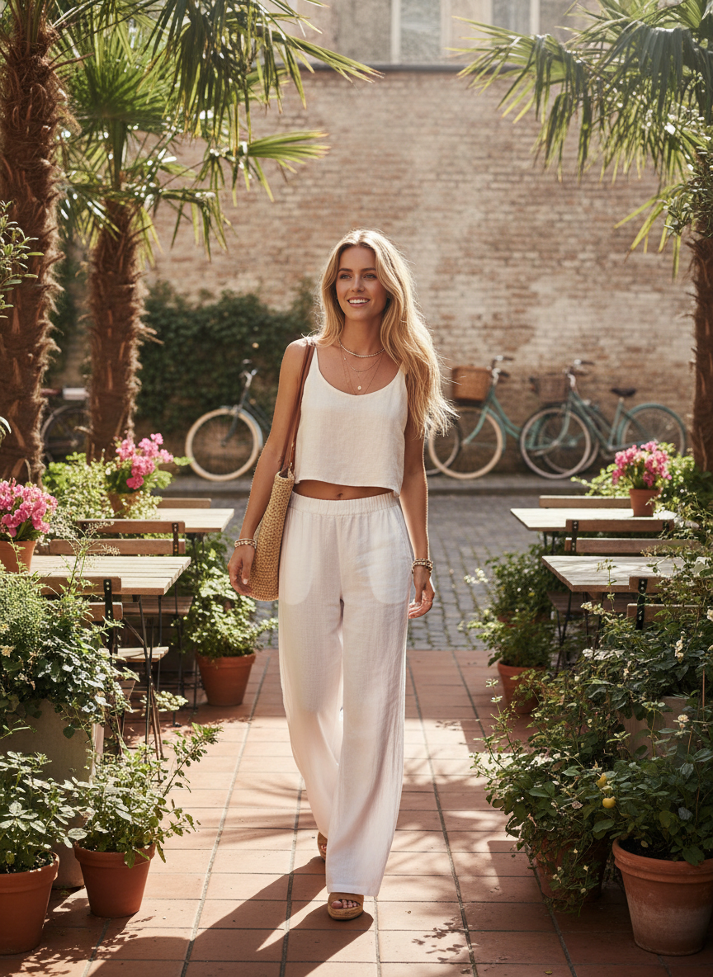

Black velvet is so sophisticated and perfect for winter. A midi length keeps it modest and classy. This fabric catches the light so well in a candlelit room. It is a simple choice that makes a huge statement. You can style this with some sheer black tights and simple black pumps.

# Satin Blouse and Wide Leg Trousers

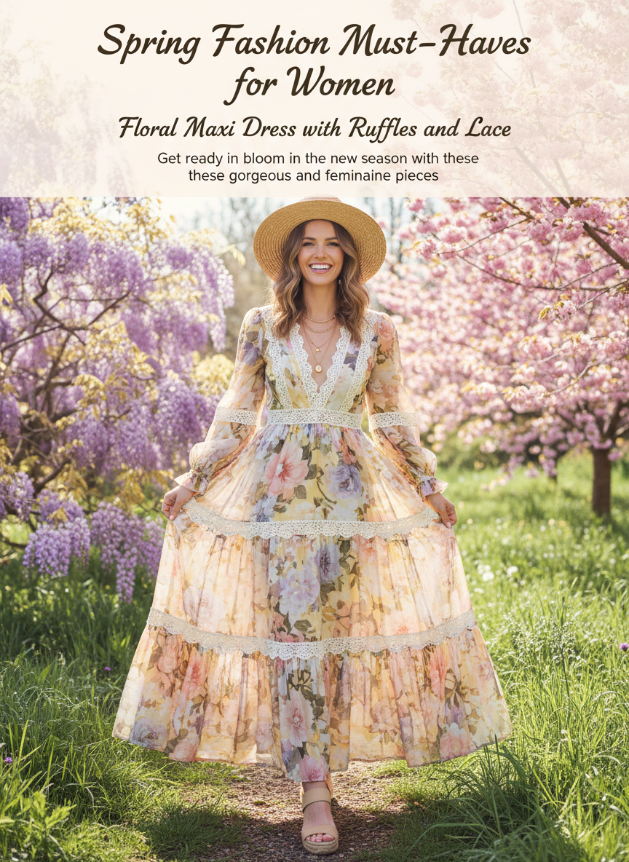

If you prefer pants over dresses, this is the way to go. High waisted white trousers look so expensive when paired with a red satin shirt. The contrast of the colors is very festive. Keep the accessories minimal to let the clean lines of the outfit show. It is a very cool and modern way to do a dinner look.

# Cashmere Crewneck and Silk Maxi Skirt

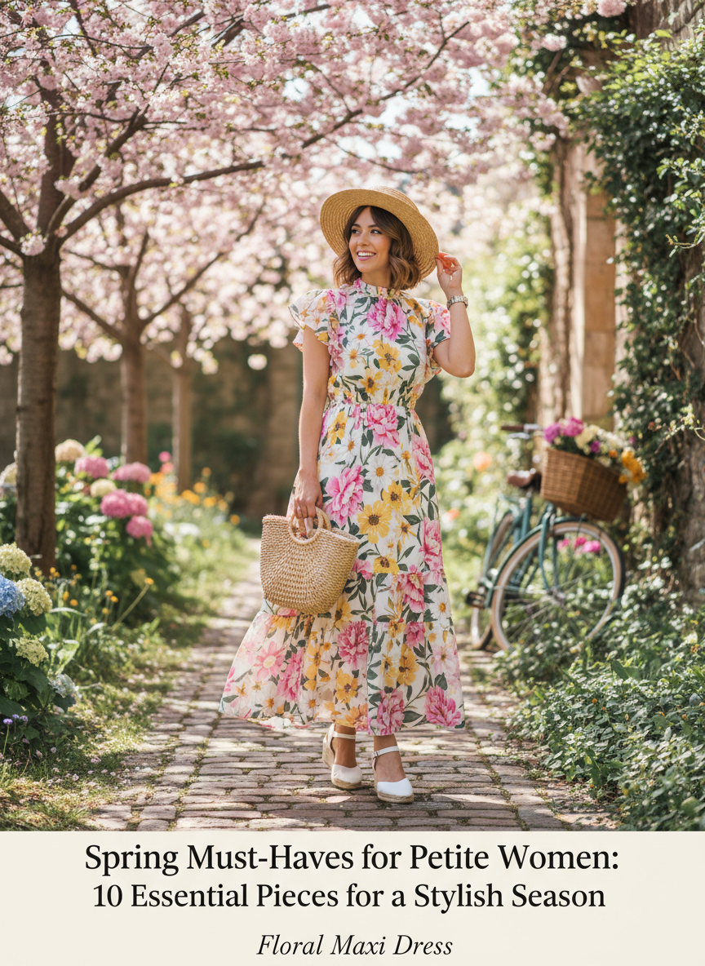

Mixing textures is a great way to look wealthy. A soft cashmere sweater tucked into a long silk skirt feels very cozy but still fancy. It is a great option if the restaurant is a bit chilly. This is one of the most comfortable 7 Classy Elegant Valentine’s Dinner Outfits (Old Money Vibe) you can choose.

# Minimalist LBD and Pearl Necklace

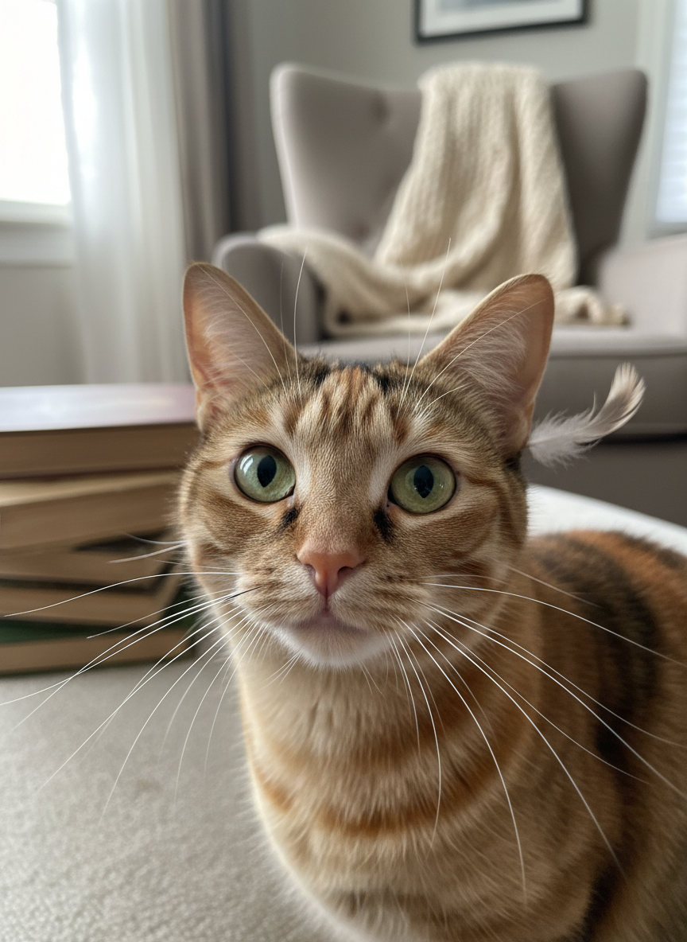

You can never go wrong with a little black dress. For an elegant vibe, choose a dress with a high neckline or a square neck. A strand of pearls adds that vintage feel that is so popular right now. It looks very polished and intentional. This is a timeless choice that will never go out of style.

# Wool Overcoat and Red Dress

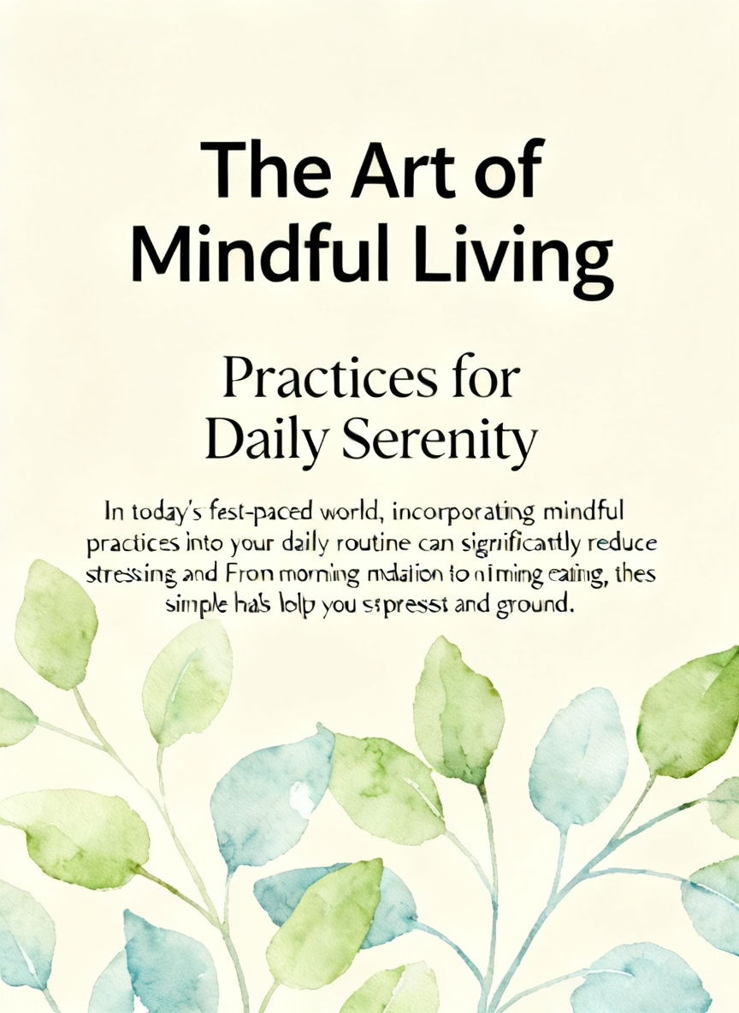

Your outerwear is just as important as your outfit. A long cream wool coat draped over your shoulders looks very chic. Underneath, a deep red dress fits the mood perfectly. It creates a very clean and striking silhouette. This look is perfect for walking from the car to the restaurant while staying warm and stylish.

# Conclusion

Picking the right look for your date night makes the whole evening feel special. These outfits focus on quality and simplicity so you can focus on having fun. You deserve to look and feel like a million dollars. These styles are easy to recreate with pieces you might already have or can find easily. Stay classy and enjoy your fancy dinner. Save these ideas to Pinterest now.